K-Means Clustering
K-Means Clustering is a popular unsupervised machine learning algorithm that partitions data into K distinct groups (clusters) and help in classification of datapoints.
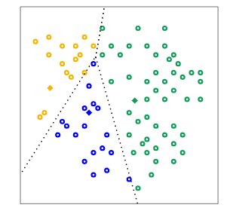
what is mean by clustering?
It is the process is which we divide the data points in dataset into number of groups such that all similar kind of datapoints are placed in same group, and this similarity is find out based on the distance between data points and the centroids.
Where it is applied?
- Data Segmentation:segmenting data into distinct groups
example, businesses use K-Means to group customers based on behavior, such as purchasing patterns or website interaction.
- Image Compression: K-Means can be used to reduce the complexity of images by grouping similar pixels into clusters, effectively compressing the image. This is useful for image storage and processing.
- Anomaly Detection: K-Means can be applied to detect anomalies or outliers by identifying data points that do not belong to any of the clusters.
- Document Clustering: In natural language processing (NLP), K-Means is used to group similar documents or articles together. It’s often used in applications like recommendation systems or news categorization.

How the algorithm works?
1. Choose k= First of all it starts with selecting the best value for “k” which is calculated by elbow method ,once it is decided then algorithm starts working on it.
2. Initialize= it randomly places k number of cluster centroids on the x, y co ordinates of graph on which all the data points are plotted.
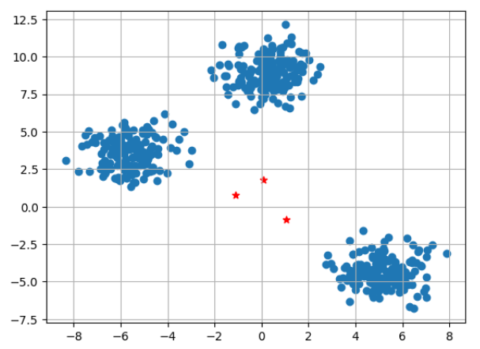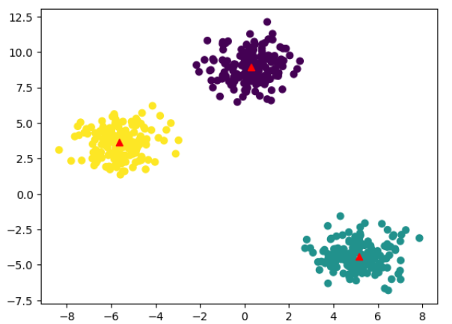
Initialize by randomly placing centroids(here we have k=3)
Finally placed centroids

3. Assign data points= calculate distance of each datapoint from the centroid and based on minimum distance from centroid classify each datapoint into that cluster.
4. Update the centroids= now relocate the centroids to the new co ordinate position and again calculate distance of each datapoint and assign it to the nearest cluster
5. Repeat the updating centroids until there is no considerable relocation in centroid position

K-Means algorithm has the following limitations:

- Choosing the Right Number of Clusters (k): One of the biggest challenges is deciding how many clusters to use.
- Sensitive to Initial Centroids: The final clusters can vary depending on the initial random placement of centroids.
- Non-Spherical Clusters: K-Means assumes that the clusters are spherical and equally sized. This can be a problem when the actual clusters in the data are of different shapes or densities.
- Outliers: K-Means is sensitive to outliers, which can distort the centroid and, ultimately, the clusters.

Methods used to measure distance:
1. Euclidean Distance:
Euclidean distance is the straight-line distance between two points in Euclidean space, essentially the shortest path, calculated using the Pythagorean Theorem.
Often called the "Pythagorean distance," it measures how far apart two points are by summing the squares of their coordinate differences and taking the square root, forming the hypotenuse of a right triangle. It's a fundamental concept used across math, physics, machine learning, and computer science to measure similarity or separation.

